Re: the forced removal of Isa Haider Al-Aali on Flight GF002 Thursday, May 22nd, at 10am
Date:

To whom it may concern

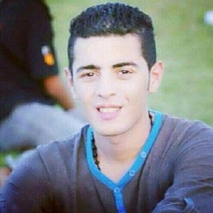
I am writing to you with grave concern about the plans to transport Isa Haider Al-Aali on a Gulf Air flight against his will. In the past, airlines such as Air France, as well as individual pilots, have refused to transport passengers on hearing evidence of unjust or inhumane removals, which is well within your legal rights. We ask you to consider the circumstances of Isa Al-Aali and, in the interest of both his safety and the comfort of the passengers and crew of flight GF002 to deny the UK removals officers permission to board with Mr. Al-Aali against his will.
Isa is a young man of 19 years who has experienced severe psychological and physical violence, including death threats, whilst under arrest for peaceful pro-democracy protests in Bahrain. He came to the UK seeking asylum, but due to lack of proper legal representation was unable to present relevant documents in time for his hearing and his request for asylum was denied. After over three months in immigration detention, he now faces removal back to Bahrain, where he has been tried in abstentia and faces 5 years in jail where he very much fears for his safety and even his life.
Since his claim was rejected, evidence has come forward from Amnesty International, the Bahrain Center for Human Rights and the Bahrain Human Rights Society, all substantiating that he has a credible risk of torture if returned to Bahrain.
There has been growing awareness of late about the judiciary use of torture in Bahrain, not least of which are the recent accusations of use of torture by Prince Nasser, himself, as reported in the Financial Times on May 12th. Isa’s case has also received social media attention and articles in the Independent and Huffington Post. In Bahrain, word of his deportation made the Gulf News and Akhbar-alkhaleej, where the government announced they are awaiting Isa’s return, denying his right to peaceful protest with veiled threats that he be deterred. That the government is anxiously awaiting his return is of grave concern; increased media attention will only serve to put him at greater risk of retribution from the Bahrain state.
We appeal to your sense of corporate morality to refuse to participate in the removal of this young man.
We further ask you to consider the impact that transporting someone against their will, whilst forcibly restrained, would have on the crew and passengers of flight GF002. Allowing him to be transported on your flight will cause him severe distress. Moreover, it is a sad but true fact that forcibly removing people from the UK has led to fatalities in the past. Surely, transporting someone against their will and in fear of their life is not in the interest of anyone on your flight.
We commend the managers, pilots and other crew of various airlines who have stopped a number of forced removals of refugees on their flights, exercising their legal rights and showing compassion and regard for their passengers’ safety. We hope we can count on you to do the same.
More information about Mr. Al-Aali’s situation can be found in a document put out by the Bahrain Institute for Rights and Democracy.
Thank you for your consideration in this matter. We trust you to do the right thing.
Yours faithfully,

